Data Request for LWI Regions 4 – 7 to identify Best Models and Base Geometry

The Water Institute

Louisiana Watershed Initiative

9/1/2023

# Summary Request

1. Review spreadsheet of model inventory to ensure all your models are there.
2. Fill in Column J to specify the best geometry file number (Ex: g.01).

# Best Models

Many models were submitted across Regions 4 through 7 to the LWI AWS S3 data repository. The Water Institute is looking through the models to determine which are the best, most current models so far.

A spreadsheet has been developed to provide an inventory of model submissions. We would request each Region look at the spreadsheet to ensure no models are missing from the inventory. It has been attached separately from this memo as model_list.xlsx

Some regions have uploaded multiple models using the same RAS project name as a duplicate. In many cases, it is obvious which is the more recent version based on the directory structure. For example, for the model in Region 6 named “EC_ELouisianaCoastal”, 4 models have been submitted with the following directories with dates included at the end of the directory pathname:

|  |
| --- |
| Region6\deliverables\20230526_TO2_Validation_Stage4\HUC8_08090203_HEC-RAS_V631_20230728\Model\EC_HEC-RAS_V631_20230728 |
| Region6\deliverables\20230526_TO2_Validation_Stage4\HUC8_08090203_HEC-RAS_V631_20230526\EC_HEC-RAS_V631_20230526 |
| Region6\deliverables\20230309_T02_Calibration_Stage3\HUC8_08090203_HEC-RAS_V631_20230309\EC_HEC-RAS_V631_20230309 |
| Region6\deliverables\20221110_TO2_Hydraulic Model Setup - Stage 2\HUC8_08090203_HEC-RAS_V631_20221110\EC_HEC-RAS_V631_20221110 |

Region 7 also has directories for Initial vs Backcheck Review models; For Example:

|  |
| --- |
| Region7\deliverables\MaurepasRASInitial\RAS\HECRAS LM_WEST\HECRAS |
| Region7\deliverables\Maurepas_RAS_Backcheck\RAS\Maurepas_West_RAS\HECRAS |

We have attempted to determine which model is the most recent and we have provided a spreadsheet of those results. Please review and let us know of any discrepancies. The green rows, and where there is Y in the final column, indicate which duplicate model is chosen as the most recent.

For example, in the screenshot below, we can see the duplicate project name is “LC_LowerCalcasieu” and the third row is chosen as the most recent model of the three, and the first two rows are considered older or preliminary models.

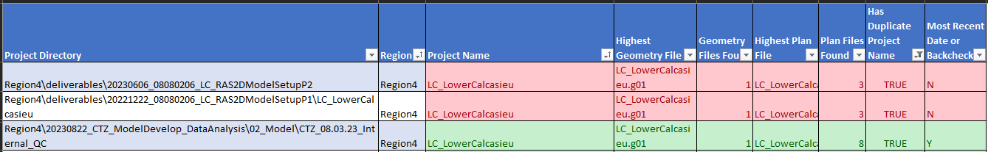

# Best Geometry

We also need to know for better metadata automation analysis of the models, which geometry is considered the best current condition geometry. The spreadsheet accompanying this memo attempts to assist in understanding what geometry files are available, and the highest number geometry.

By default in HEC-RAS, when a new geometry file is created it gets assigned a file name extension of {project name}.g##, where ## is the lowest available number from 0-99 that is not already been assigned to a previous geometry file. Often the highest geometry file number in the model directory is the most recent, but we would like to verify that before assuming, as it isn’t true if cleanup of geometry files has occurred that deleted older, lower number files with new ones created after that would use those lower number values.

Additionally, there may be higher number geometry files that represent future-conditions. We would like to know the best geometry file for current conditions within each model.

So please fill out the spreadsheet for your respective region to provide this information under Column J “Region Specified Best Geometry File” with the best geometry filename extension, for example “g.01”.

We will not need this information for any of the red rows depicting older duplicate models, so these rows have been prefilled with “NA”, but the rest of the rows should be filled out. We have prefilled any models that are found to have a single geometry file as seen in the screenshot below.

